NEW ZEALAND

New Zealand's spectacularly beautiful landscape includes vast mountain chains, steaming volcanoes, sweeping coastlines, deeply indented fiords and lush rainforests. Comparable in size and/or shape to Great Britain, Colorado or Japan, New Zealand has a population of only 4 million - making it one of the world's least crowded countries. It is a haven for those seeking peace, rejuvenation and relaxation as well as a playground for thrill seekers and adventurers. A temperate climate with relatively small seasonal variation makes it an ideal year-round holiday destination.

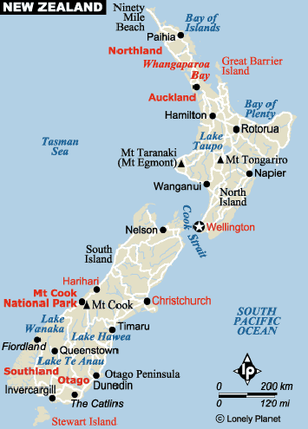

GEOGRAPHY:
New Zealand is situated in the Southern Hemisphere, 2,000km south-east of the Australian landmass. The country proper is divided into two large islands (North and South) and many smaller and more scattered islands. The larger island is South Island, often referred to by its inhabitants as the "Mainland". North Islanders, though, tend to condescend to the Mainlanders as a bit behind the times and very rural. The existence of the country's "Cultural City", Christchurch, shows how wrong this generalization is.

VISA : The visa is to be obtained prior to arrival in the country.

HOW TO GET THERE:
INTERNATIONAL AIRPORT: There are seven international airports in New Zealand namely Auckland Airport, Christchurch airport, Dunedin airport, Hamilton airport, Queenstown airport, Wellington airport & Palmerston North airport

FLIGHTS INTO NEW ZEALAND:
Singapore Airlines, Air New Zealand, Qantas, Thai airways

CURRENCY:
New Zealand Dollar (NZD). NZD1=100 cents

GETTING AROUND:
Air: New Zealand is about 1,000km long - with a wide strait in the middle, which precludes driving from end to end in under two exhausting days.
Not surprisingly, many people choose to fly instead: a flight from Auckland to Christchurch will take about two-and-a-half hours and from Wellington about one hour. These three cities are also New Zealand's main international airports.

Domestic airports are located at Hamilton, Palmerston North, Queenstown and Dunedin. These four also receive flights from Australia as well as internally within New Zealand. The main domestic carriers are Air New Zealand and Qantas New Zealand There are also a host of smaller airlines and charter companies in the less densely populated regions.

There is a NZD25 international departure tax levied on all out-going passengers. This may be included in your air fare but is more likely to be payable at the airport. Even tickets bought in New Zealand do generally not include departure tax.
Train: Cross-country rail travel in New Zealand is not the quickest means of getting from one place to the next - which is half the charm. You'll notice that most other passengers are visitors to the country as well, enjoying the scenery and kicking back as the pace slows down.
Tranz Scenic (the only inter-city rail network) runs three routes covering South Island and four covering North Island, all of which will get you pretty much anywhere you want to be.
Bus: Getting around New Zealand by coach is a good option for visits to the major cities and towns, especially since you end up being able to have a decent look at the countryside.
The major coach company is Inter City, which has an extensive network across both islands. Don't misjudge distances, though: a trip between Auckland and Wellington will take about 11 hours. Smaller "shuttle" and minibus companies abound, too, and can be more fun as you'll get to speak with the driver and meet local passengers - check with tourist information offices for services and availability.
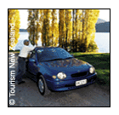
Car: The road system in New Zealand is generally good, with major cities connected by highways. Driving is generally safe in the country with a low level of traffic accidents. It is unlikely you'll be shipping your own vehicle to New Zealand, so to obtain a vehicle the usual option is hiring. All the big international car hire companies have offices in NZ. This means there's no problem getting rental cars at any of the main airports or towns.
Although unlikely to be an option for a short holiday, for protracted stays in New Zealand (several months usually) some people take the option of buying a car and selling it at the end of their stay. For this reason some car sellers operate Buy and Sell-back schemes whereby they guarantee to buy back the vehicle at a reduced price after a certain length of time.
Points to consider:
• Your national driving licence is valid for use in New Zealand. If the licence is not in English, however, you should obtain a translation or an International Driver's Licence.
• You must carry your driving licence with you at all times when driving.
• The road system in New Zealand is generally good, with major cities connected by highways.
• The speed limit is 100km per hour (62mph) on the open road and 50km per hour (31mph) in built up areas. Limited Speed Zones (marked by a red circle around the letters LSZ) apply on some stretches of highway where in adverse weather conditions you must reduce your speed to 50km per hour. At other times the 100km per hour limit applies.
• Driving is on the left and you must overtake on the right.
• The driver and all passengers must wear seat belts where fitted.
• Roads tend to be uncongested and you shouldn't experience many problems navigating, even in cities.
• Drink driving is illegal with a blood/alcohol limit of 80mg per 100ml of blood. For drivers under 20 the level is 30mg per 100ml. Random roadside tests are carried out frequently.
The following table provides approximate driving distances between New Zealand cities. Kilometers in the lower left of each table, miles in the upper right:
North Island | Auc | Ham | Rot | Nap | Wan | Wel
Auckland | • | 79 | 145 | 263 | 284 | 409
Hamilton | 127 | • | 66 | 184 | 206 | 331
Rotorua | 233 | 107 | • | 139 | 192 | 286
Napier | 422 | 296 | 224 | • | 157 | 201
Wanganui | 457 | 331 | 309 | 252 | • | 121
Wellington | 658 | 532 | 460 | 323 | 195 | •

South Island | Chr | Dun | Inv | Tim | Nel | Que
Christchurch | • | 225 | 359 | 101 | 263 | 302
Dunedin | 362 | • | 135 | 124 | 496 | 175
Invercargill | 578 | 217 | • | 258 | 631 | 117
Timaru | 163 | 199 | 416 | • | 367 | 208
Nelson | 423 | 799 | 1016 | 591 | • | 528
Queenstown | 486 | 281 | 189 | 335 | 850 | •
Boat: The Cook Strait is 26km wide at its narrowest and 400km at its widest point - far too wide to bridge. The ferry link is naturally essential for traffic between the islands.
The three-hour "InterIslander" ferry trip across the Cook Strait from Wellington (NI) to Picton (SI) is an attraction in its own right. The last hour or so through Queen Charlotte sound is utterly beautiful on a good day, and you start to slow down to the tempo of South Island before you've even arrived. There's also the Lynx - a "wave-piercing" catamaran that does the trip in just over two hours, but with less of a view.
BUSINESS HOURS:
Banks are open from 9.30am to 4.30pm Monday to Friday.
Most shops are open from 09h00-17h00 Mon-Fri. Many larger stores will open on Saturday and some Sundays. In busy tourist resorts shops remain open later into the evening.

CLIMATE:
New Zealand is a great destination to visit all year round. It has four distinct seasons, which are the reverse of those in the Northern Hemisphere. Spring falls between September to November, summer from December to February, autumn from March to May and winter from June to August.
Considering that the two islands stretch almost 2,000km (1,240 miles) from north to south, it is not surprising that you can experience a very different climate in different parts of the country. The Northern tip of the country is subtropical, while the south is temperate and can be quite cold in winter.
New Zealand is a breezy country, especially Wellington, which is known for spells of quite windy weather.

CLOTHING:
Dress is informal and relaxed on most occasions. Smart casual clothes are acceptable at most restaurants and night-spots. Men are generally not expected to wear suits and ties, except in a few of the top formal bars and restaurants in major cities.

In summer a light jacket or sweater should be included in your luggage should the weather turn cooler or you visit higher altitudes. You can expect some rain, so include a light rainproof jacket or coat. If visiting between May and September, pack warm winter garments and layer your clothing.

TIME:
New Zealand is 7 hours and 30 mins ahead of us

ELECTRICITY:
Electricity is supplied throughout New Zealand at 230/240 volts, 50 hertz. Most hotels and motels provide 110 volt ac sockets (rated at 20 watts) for electric razors only.
For all other equipment, an adapter/converter is necessary, unless the item has a multi-voltage option. Please note that power outlets only accept flat 3 or 2-pin plugs, depending on whether an earth connection is fitted.

DIALING CODE:
International code: +64
North Island North (inc. Auckland): 9, North Island Central and Eastern (inc. Hamilton): 7, North Island Western (inc. Napier): 6, Wellington Region: 4, South Island (inc. Christchurch): 3

TIPPING:
Don't tip. Not even in restaurants. Tipping is just not done in NZ - it's not expected of you, and staff are paid enough in their normal pay packet so as to not need tips. However, not tipping at a restaurant can feel very odd for many travellers, and it's a rare waiter who will turn a tip down if it's offered.

LANGUAGE:
English is the common and everyday language of New Zealand. New Zealand is a multi-cultural society and you may hear many other languages spoken, including Maori, which is also an official language of New Zealand.

SAFETY:
New Zealand is one of the safest travel destinations in the world, with a relatively low crime rate, few endemic diseases and a first-class healthcare and accident compensation system. However, we recommend you observe the same precautions with your personal safety and your possessions as you would in any other country or at home.
- Keep copies of your important documents, eg passport and credit cards, and keep them separate from the originals.
- Keep a record of the description and serial number of valuable items, eg digital cameras.
- Dial 111 in emergencies.

FOOD
New Zealand's cuisine has been described as Pacific Rim, drawing inspiration from Europe, Asia and Polynesia. This blend of influences has created a mouth-watering range of flavours and food in cafes and restaurants nationwide. For dishes that have a distinctly New Zealand style, there's lamb, pork and cervena (venison), salmon, crayfish (lobster), Bluff oysters, paua (abalone), mussels, scallops, pipis and tuatua (both are types of New Zealand shellfish), kumara (sweet potato), kiwifruit, tamarillo and pavlova, the national dessert.
Its distinctiveness is more in the way New Zealanders eat, generally preferring as relaxed and unaffected as possible, in keeping with the laidback Kiwi psyche.

NORTH ISLAND
AUCKLAND:
Imagine an urban environment where everyone lives within half an hour of beautiful beaches, hiking trails and a dozen enchanted holiday islands. Add a sunny climate, a background rhythm of Polynesian culture and a passion for outstanding food, wine and shopping - you’re beginning to get the picture of Auckland.

Key Tips
- Auckland has the largest international airport in New Zealand. Two domestic terminals allow frequent and accessible flights throughout the country.
- Auckland is on four touring routes - Twin Coast Discovery, Pacific Coast Highway, Thermal Explorer and the Great New Zealand Touring Route
MUST SEE:

Sky Tower & Harbour Bridge
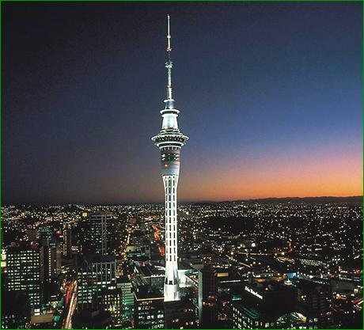
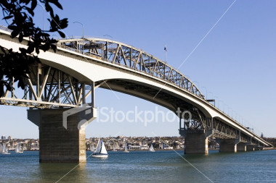
Auckland is a huge, largely low-rise city that sprawls across the heart of the North Island. Its two most commanding landmarks - alongside the wind-filled sailboats hugging the harbour shoreline - are the Harbour Bridge and the Sky Tower, which, at 328m, is the tallest structure in the Southern Hemisphere, and towers above the city skyline. A good way to become acquainted with the city layout is by paying a visit to the tower's viewing platform, which provides superb vistas over the city and surroundings.
For a truly bird's eye overview, a good alternative is the recently-opened Harbour Bridge Climb. In true Kiwi adventure style, you can strap on climbing gear and clamber up to the upper level of the Auckland Harbour Bridge. Full safety equipment is provided and you don't need any experience of climbing, though you will need a head for heights. Open: daily.
The more daring still will enjoy the thrill of New Zealand's original extreme sport (New Zealand invented the bungee jump) by taking the plunge off the bridge.
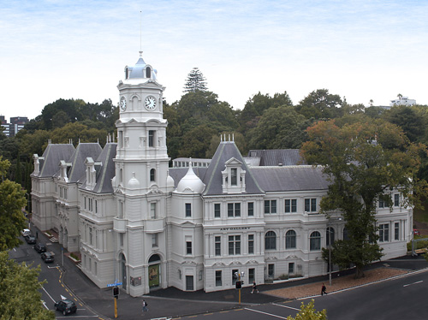
Auckland Art Gallery - Toi o Tamaki
Smack bang in the middle of town is the Auckland Art Gallery, Toi o Tamaki. Arranged over two adjacent sites, the excellent gallery - the most comprehensive in the country - features work of New Zealand and Pacific Island artists along with a fine European collection and is host to leading international exhibitions. One of the highlights is the display of contemporary Maori artwork, including some great sculpture, painting and photography, though many visitors will be lured by the notable selection of Italian, Flemish and English Old Masters and the Modern European works by luminaries such as Magritte, Chagall and Picasso.
Open: daily 10h00-17h00. Admission: free to general gallery
Free daily tours at 14h00.

Auckland Museum & the Domain Park
The Auckland Museum in the Domain - the city's oldest park - has recently emerged from major renovation (the final phase of which, the Grand Atrium, completes in 2006) and is one of the country's leading historical museums, housing the world's greatest collection of Maori taonga - treasures - including three complete buildings and a waka taua (war canoe) from the 1830s.
Maori cultural performances are staged three times daily and are well worth watching, especially if you haven't seen any such live performances before. The museum's dual role is as the city's War Memorial, offering a powerful insight into New Zealand at war from the late 19th century to the present day. The heart of this is the Hall of Memories, where the names of the men and women from the Auckland provinces who lost their lives for their country are carved into the marble walls.
The Domain Park. Museum open: daily 10h00-17h00.
One-hour museum highlights tour: daily 10h30.

Cornwall Park & One Tree Hill
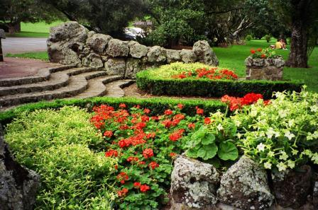
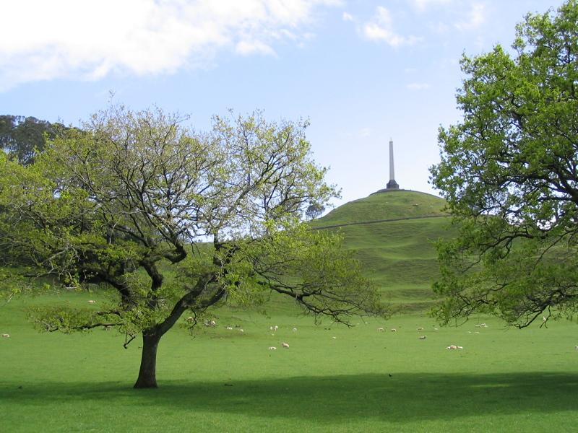
Another park worth visiting in its own right, Cornwall Park is home to roaming sheep and New Zealand's oldest building, Acacia Cottage, originally the residence of "father of Auckland" Sir John Logan Campbell, the prominent 19th-century politician and businessman. The pretty white timbered house was built in 1841 and is furnished in the style of the period, making it fascinating for budding social historians.
The park surrounds One Tree Hill, a volcanic cone made famous by rock band U2, who fell in love with the site when they first visited Auckland in the 1980s and immortalised it in a song of the same name. Of great spiritual significance to the Maori, many of the remains of a pre-European fortified encampment known as a "pa", built here centuries ago, can still be seen today.
Park open: daily 07h00-dusk. Acacia cottage open: 07h00-dusk (summer); 07h00-16h00 (winter).

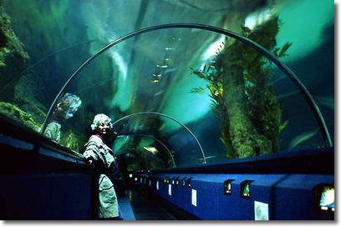
Kelly Tarlton's Antarctic Encounter & Underwater World
Kelly Tarlton's Antarctic Encounter & Underwater World quickly became one of Auckland's top attractions when it opened in the 1980s. The original 110-metre-long acrylic tunnel running underneath Auckland's waterfront that thrilled visitors able to walk among sharks, stingrays and
myriad other aquatic life is still there, and has been added to over the years.

However, the man-made landscape of ice and snow that is home to gentoo and king penguins, and the life-size model of Antarctic explorer Captain Robert Falcon Scott's hut are undoubtedly the star attractions.
Open: daily 09h00-18h00.

Viaduct Basin
Visitors to the city quickly learn how it earned its nickname of The City of Sails. The Waitemata Harbour provides a glistening backdrop to the pace of urban life and is a focal point for tourists and Aucklanders alike. Key to this is the recently regenerated Viaduct Basin (off Quay Street, Downtown), also known as the America's Cup Village. New Zealand might have lost the trophy in 2003 but it's unlikely to have any great effect on the waterfront buzz - the area bustles with open-air restaurants and cafés throughout the busy summer months and is a great place to just relax and soak up the atmosphere.

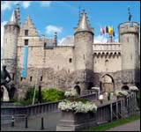
National Maritime Museum & Sailing Excursions
A bastion of New Zealand's nautical heritage, the National Maritime Museum offers a fascinating insight into the country's seafaring history from the arrival of the first Maori settlers to the America's Cup.
Open: daily 09h00-18h00.

This said, an arguably better way to understand locals' love of the water is to get out and experience it firsthand. Numerous companies offer sailing experiences,

Hauraki Gulf Islands
The islands in the Hauraki Gulf just off the Auckland coast are great for daytrips.
Laid back and bohemian with a decidedly artsy vibe and excellent vineyards, Waiheke is a favourite and only 25 minutes away by ferry. Visit in February if you can for the annual Jazz Festival.
Guarding the entrance to the gulf, the silhouette is instantly recognisable to visitors of Rangitoto Island. A 600-year-old dormant volcano, it is home to lava trails and the world's largest pohutukawa (New Zealand's Christmas tree) forest, while world-renowned bird sanctuary Tiri Tiri Matangi is home to a number of endangered birds, including the extremely rare takahe and the kiwi.
Ferries to Waiheke Island run approximately hourly Mon-Fri 05h30-23h45; Sat 06h30-23h45; Sun 07h00-21h30.
Ferries to Rangitoto: daily 09h15, 12h15 & 15h15.

Howick Historical Village and Glenbrook Railway
For a glimpse into Auckland's past, Howick Historical Village is an interactive "living" museum offering a glimpse of life in Auckland in the 1850s. This and other so-called fencible villages were created for pensioned soldiers from the British army who were lured into emigrating by the promise of free passage, guaranteed work and a cottage. Interesting - and quite convincing - live days, when costumed actors recreate 19th-century village life, are held on the third Sunday of every month.
Open: daily 10h00-16h00.
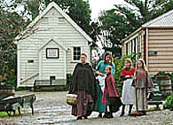

Glenbrook Railway is another interesting historical attraction. Home to restored vintage steam and diesel trains from the Victorian era it is more than a transport museum; visitors are able to chug 6km up and down a fully operating vintage railway in a restored steam locomotive. A great place for secret (or not so secret) trainspotters. Glenbrook Railway, 38 Alfred St, Onehunga.
Open: Sun & public holiday weekends (Oct-Jun).

Auckland Suburbs
Auckland's suburbs each have a rich and distinctive flavour. The spine of the city centre is Queen Street, heart of the Central Business District and bustling with the pace of urban office life. To the east is the laid back sophistication of Parnell, with its numerous art galleries and restaurants, while Ponsonby to the west of the city centre is full of stylish and original shops along with cutting-edge cafés and bars.
For a little beachside action with your café culture, travel past Parnell along Tameki Drive to picturesque Mission Bay, while over the Harbour Bridge, the Takapuna beachfront attracts a youthful surf crowd.
Also on the North Shore is Devonport, an area best reached by a 12-minute ferry ride across the Waitemata Harbour from central Auckland with a pretty, villagey feel. Twin volcanic peaks overshadow it: Mount Victoria, once the site of a Maori Pa, and North Head, a former artillery battery built in the late 1800s to defend the city from invasion. The tunnels running under the mountain are open to public view. Ferries depart from Ferry Building, Quay Street.
There is much for visitors to explore in the greater Auckland area too. One of the best ways to do this is to follow the Winetrail. Pick up a leaflet at any tourist information centre and strike out on your own or sign up with an organised tour.

AUCKLAND EXCURSIONS:

Bay of Islands
Centered around the town of Paihia, the Bay of Islands, as the area was named by Captain Cook, consists of 140 beautiful subtropical islands off the east coast north of Auckland. With its white sandy beaches and lush natural beauty, combined with a number of historical attractions, this is understandably one of the top tourist destinations in New Zealand.
You need to spend a few days here ideally to get the most out of your stay, though if you're short of time it's possible to go on a day trip from Auckland which takes in the top sights.

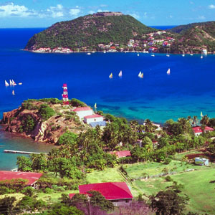
There are numerous boat trips out to the islands, from visits to Cape Brett and the curiously-shaped (and rather unimaginatively named) "hole in the rock" to whale-watching and diving trips. For history fans, the town of Waitangi is of interest, as this is where the treaty of the same name was signed in 1840 that gave the British sovereignty over New Zealand. Nearby Russell has a colourful history as a playground for early traders - the town still has a number of attractive Victorian streets, as do several other towns in the region.

Waitakere and the West Coast
Northwest of Auckland, the mountains of the Waitakere Ranges offer superb walking trails through native bush, and are one of the best places to explore the wilderness within easy reach of the city.
Nearby on the west coast, the black sand beach at neighbouring Piha is a favoured haunt of local surfers. Piha has a long history as a surfing destination but is not for novices - waves often top three metres here. Another top surf beach just north of Piha, Muriwai, has an added attraction: it is home to a colony of gannets. At Takapu gannet colony visitors have the unique opportunity to get close to these rare birds and watch them coming in and out of their nests on the cliff tops. The area is also famed for its ancient kauri trees, which are sadly now an endangered species. You can spot a number of them in the nearby forest and bush, along with all sorts of other indigenous wildlife.

Mauao (Mount Maunganui)
Guarding the entrance to Tauranga Harbor, Mauao was the landing place of the Takitimu waka. Takitimu was one of the ocean-going migration canoes that made the trip from Hawaiki to New Zealand in about 1290 AD.

White Island
Walking on an active volcano is a once in a lifetime opportunity. White Island hisses, fumes, belches and rumbles with geothermal action. It’s accessible by launch and helicopter from Whakatane.

Key Tips
- Tauranga and Mount Maunganui are just 2 ½ hours drive from Auckland, on the picturesque Pacific Coast Highway.
- 70% of New Zealand’s kiwifruit is grown in Te Puke - the kiwifruit capital of the world which is in this area.
- White Island is a highly recommended Thomas Cook excursion that all must do, if u are doing a self drive. To illustrate how the itinerary should look – drive from AKL to Rotorua, spend a couple of days in ROT and then drive to Whakatane ( takes 1 hr 30 min ). Spend the night. The next morning do the day excursion to the White Island ( the only thing is that this is an excursion that is completely dependent on the weather). Another night in Whakatane. Next morning drive to ROT Airport for flight out or continue driving as the case may be.

Nightlife
Auckland is home to the country's best nightlife. Many ordinary bars stay open until well into the early hours, some with DJs. For serious clubbing though head for the city or around K Road. This area, connecting the top of Ponsonby Road to Upper Queen Street, was once a no-man's land of seedy strip joints, but has been reinvented as the scene of Auckland's most cutting-edge nightlife.
For dance music, check out the likes of Kiss Club or Fu Bar
Live gigs are widely performed and Auckland is firmly on the tour map for international acts. Check out the likes of Papa Jacks to hear home-grown Kiwi talent.

Casinos
Sky City offers music, comedy and cabaret in its theatre and is home to Auckland's casino, open 24 hours a day, seven days a week.

ACCOMMODATION IN AUCKLAND:
Auckland offers a good choice of accommodation, from traditional B&Bs to international hotels. Conveniently, the majority of hotels are right in the city centre, around Hobson Street, Victoria Street West and Albert Street. This means that they're within a stone's throw of many of the main attractions, such as the Sky Tower and Auckland Art Gallery, as well as being within easy reach of the harbour and a good choice of shops and restaurants.

INDIAN RESTAURANTS:
Satya South Indian Café
Bolliwood
Chutneys
Jewel of India - Mission Bay
Little India
Oh Calcutta Restaurant
Santoor
Shahi
Shahi Cafe - Herne Bay
Sitar Indian Restaurant
Tulsi
Wishing Well of India - Browns Bay
Wishing Well of India -Orewa,
Wishing Well of India- Manukau
Ajadz Indian Café
Masala Cafe & Bar
Moghul
Curry heaven

ROTORUA
Rotorua (pronounced Row-toe-rue-a) is situated in the North Island of New Zealand. Famous for its geothermal activity the area was originally settled in the 14th century by the Te Arawa people, so named as they arrived in the Te Arawa Canoe from Hawaiki, the mythical home of the Maori peoples situated somewhere in Eastern Polynesia. In the 19th century the tribe began hosting visitors after newly arrived settlers to this strange wild country began journeying to Rotorua in order to see the famous Pink and White Terraces at Lake Rotomahana. This tradition continues to this day with descendents of the original tribe hosting tourists from all around the world.

MUST SEE:

Rotorua Museum
At the Rotorua Museum you will see, hear and even feel the great stories of Rotorua, especially during the high impact cinema experience ‘Rotorua Stories’. The Rotorua region has a fascinating past.
The spectacular Pink and White Terraces, the devastating eruption of Mount Tarawera, the story of the world famous Bath House, the rich history of the Arawa people and the exploits of B Company 28 Maori Battalion are portrayed in exciting, innovative exhibitions that capture the imagination of all ages.

Geyser at Wai-O-Tapu Thermal Wonderland
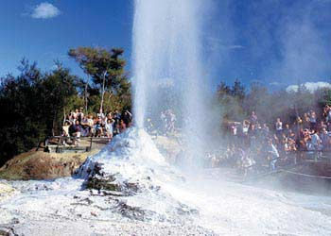
Rotorua’s premier geothermal attraction is in New Zealand’s most colourful volcanic area, Wai-O-Tapu Thermal Wonderland. Colours of every tint and hue are displayed in pools, lakes, craters and steam vents. See the pristine beauty of the ‘Champagne Pool’, ‘Artists Palette’ and ‘Primrose Terrace’. Listen to the songs of birds as you walk through native forest.

Tamaki Village

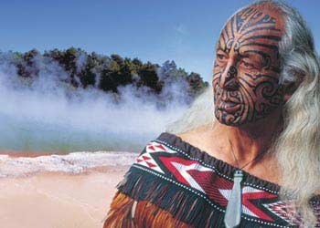
A world of ancient Maori and proud warriors await visitors to the Tamaki Maori Village. The recreated pre-European Maori Village includes a nightly cultural experience, performance and feast (hangi). Also, a market place with exhibitions and sales. You are collected from accommodation for the night time experience, which is located 15 minutes’ south of Rotorua deep in the forest and 20 minutes’ North of Taupo.

Paradise Valley
This is a Bird and Wildlife park . A superb nature park of native bush with crystal clear trout pools housing Rainbow and Brown trout. Underwater viewing cave, wetlands and animal and bird life. Home to Te Waireka (Sweet Water) Spring.

Polynesian Spa
New Zealand’s leading thermal bathing complex, voted as one of the best 10 top spas in the world by the recognized Conde Naste magazine. Comprising various pools with varying temperatures, the Priest Springs, Adult pool and family areas offer superb thermal bathing. The spa is walking distance from the lovely and highly recommended Millinneum Rotorua hotel. One needs to make a reservation in advance for the various treatments if needed.

Skyline Gondola
Ride the most modern Gondola in the Southern Hemisphere to the best Panoramic Views of Rotorua. Extensive panoramic views of the city, lake and surrounding district. Fully licensed restaurant serving buffet lunches and dinners and Food Court for casual dining.
Enjoy the ride on the Luge here - A world first, proudly built and designed in Rotorua, take the scenic track for your first ride, a 2 kilometer ride through the Redwood trees, stop at scenic points along the way to take photos. Fun for all ages and children under 6 can be carried in tandem.

WAITOMO CAVES
The place is a 3 hr drive from AKL. Its normally done as a stopover enroute to Rotorua. One also combines this with a stopover at Whakarewarewa Thermal Geysers. Once in Waitomo, during your 45 minute guided tour, you'll take in the spectacular Glowworm Cave with its majestic and ornate cave decorations, the deep limestone shaft known as the Tomo and the equally magnificent Cathedral cavern where New Zealands own opera diva Kiri Te Kanawa once performed. Your tour guide will deliver an informative and entertaining commentary, sharing stories, cultural legends and the natural wonders of this living masterpiece. The tour concludes with a boat ride in the grotto.

LAKE TAUPO
The Lake Taupo region in New Zealand's volcanic heartland is rich in Maori tradition. It also has some of the country’s finest untouched, uncrowded and unique landscapes. The lake itself was the result of the most violent volcanic eruption the world has seen in the past 5000 years - the ash affected the sunsets as far away as Europe and China.
It’s a great place to spend a couple of days if one would not like to stay in Rotorua. The distance is around 1 hr apart.
Lake Taupo also has some very exclusive resorts which can be booked.
Jetboating is very sought after here and can be pretty exhilarating. A must do whilst here. Rotorua is the closest airport to Lake Taupo.

WELLINGTON:
Capital of New Zealand and geographical centre of the country, Wellington is known for its lively cultural scene and progressive outlook.
Situated at the bottom of North Island, the city is organised around its splendid harbour while areas of outstanding natural beauty are located only a short drive away from the compact Wellington city centre.
It's often observed that Wellington has all the sophistication of an international metropolis combined with the charm of a local village. To others, though, Wellington is the windy city - subject to gale force gusts and lots of hot air from the politicians!
Everyone agrees, though, that this is a beautiful place, packed with great restaurants and visitor attractions that make the most of its abundant natural virtues.

MUST SEE:

Harbour
For many visitors, the number one attraction is the location: sea and mountain vistas overlook a peaceful harbour that bringing in the freshness of the sea breeze. To explore the harbour, catch the Evening Post ferry from Queens Wharf to Somes Island, and then on to Days Bay for some lunch or dinner.
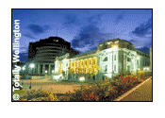
Te Papa
Other highlights include Te Papa, New Zealand's superb national museum, recently given a NZD350 million makeover. Te Papa has substantial multimedia, hands-on and interactive displays, which bring to life the country's culture and landscape. Cable St. Open: daily 10h00-18h00 (until 21h00 Thursday). Admission: free.
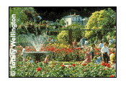
Parliament buildings
Another good bet is the restored Parliament Buildings designed in three distinct architectural styles, ranging from the Victorian Gothic library to the unique 1970s-style Beehive building. Admission: free.
Old St Paul's church
Nearby Old St Paul's Church is a 19th-century Gothic masterpiece made from native timbers and stone, punctuated with wonderful stained glass windows.
Carter Observatory
If it's a clear day, take the cable-car up to the Carter Observatory and access the 26 acres of bucolic bliss that is the Botanic Gardens. More highlights are found in Wellington's funky urban districts such as Cuba Street, Willis Street and the Lambton Quay complex.
Museum of Wellington City and Sea
The Museum of Wellington City and Sea is the city's newest museum and its
stimulating displays trace Wellington's history and identity through its relationship with the sea. Although modest in size, this young museum excels in its integrated audio-visual features and interesting exhibits.
Open: daily 10h00-17h00. Admission: free.

Karori Sanctuary
The Karori Sanctuary is a 250-hectare wildlife park set in a lush valley only 2km from Wellington city centre. The pristine rainforest is home to rare native fauna and flora, and visitors have the option of being educated on the valley's human and ecological history by trained volunteer hosts. Departing every 15 minutes from the city, buses 12, 17, 22 or 23 will get you to the entrance gateOpen: 10h00-16h00 (Mon-Fri); 10h00-17h00 (Sat-Sun).

INDIAN RESTAURANTS IN WELLINGTON:
Daawat
Kashmir Cuisine
Little India
Masala

ACCOMMODATION IN WELLINGTON:
Downtown Wellington is the home of nightclubs, pubs, theatres and cinemas. If you like being in the thick of it then consider staying somewhere between Oriental Bay (a desirable bayside residential area) and Cuba Street (a street of great character and history). The pub scene here is rocking, shops are buzzing and the buskers (on a fine night) are pumping.

One of Wellington’s older areas, Thorndon is close to the business district, Parliament Buildings and Wellington's golden mile of shopping, Lambton Quay. Close to the lovely Botanic Gardens and only a short walk from Wellington's waterfront, Thorndon has a character all of its own. Whether you are looking for historic character accommodation or top of the range hotels this is the area to visit.

SOUTH ISLAND:

CHRISTCHURCH
Christchurch is tagged as New Zealand's Garden City. This verdant core, along with the Avon River, a spread of Victorian architecture, and the avenues and squares, are almost entirely responsible for the reputation of "Englishness." Plus, with over 50 adventure products to offer, the city is a mecca for anyone who likes a racy edge to his or her holiday. Whether you choose leisurely days discovering the city's cultural foundation or adrenaline-pumping outdoor activities, you'll find that conservative old Christchurch can dish up a few surprises.

MUST SEE:

Botanical Gardens
The turquoise-and-yellow Peacock Fountain just inside the main gate on Rolleston Avenue is a handy marker that can't be missed. This is the best point of entry to the lush 23 hectares (57 acres) of deservedly world-renowned gardens. Even if you've never considered yourself the slightest bit green-thumbed, there's something magical about this place. Sweeping lawns, fragrant rose gardens, and some of the oldest exotic trees in New Zealand provide spectacular displays year-round. The Avon River and its huge duck population add interest. The kids can run loose, feed the ducks, and frolic in the playground. Don't miss the lush tropical greenhouse, or the heavenly scented rose gardens adjacent to it. I also love the little alpine garden area and the two ponds that border the rhododendron and azalea gardens.

Timings: daily from 7 am to 1 hour before sunset

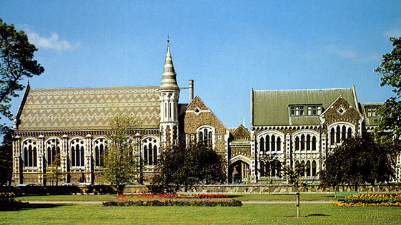
Canterbury museum:
Perfectly placed on the edge of the Botanic Gardens within a stone's throw of the Arts Centre, the Canterbury Museum is a must. Check out the excellent Antarctic display, a must-see before going out to the International Antarctic Centre. Also look for the superb Natural History Discovery Centre, where you can happily pull open drawers and inspect the contents of jars and cases. The quaint Victorian Canterbury street is interesting, and there's an excellent Maori section.

Timings: Oct-Mar daily 9am-5:30pm; Apr-Sept daily 9am-5pm. Free guided tours Tues-Thurs 3:30-4:30pm
Closed Dec 25

Christchurch Art Gallery Te Puna o Waiwhetu
The new and sparkling architectural icon has rapidly established itself as the place to go since its 2003 opening. Curving glass facades and spectacular outdoor sculpture aside, it has one of the largest permanent collections in New Zealand, and with eight new gallery spaces, there's plenty of space for both contemporary and historic displays. The collection of over 5,500 paintings, sculptures, prints, drawings, and crafts emphasizes work from the Canterbury region, but there are regular touring international and national shows as well.

Timings: Daily 10am-5pm (Wed till 9pm). Free guided tours daily at 11am and 2pm, and Wed at 6:30pm and 7:30pm. Cafe Mon-Fri 9:30am-late; Sat 8am-late; Sun 8am-5:30pm
Closed Dec 25

Christchurch Gondola
The Christchurch Gondola may not have quite the same breathtaking impact as the Queenstown equivalent, but for unparalleled views westward over the city and the Canterbury Plains to the Southern Alps, and for the full sweep of Pegasus Bay and the Pacific Ocean all the way up to the Kaikoura Ranges, you can't beat it. Perched on the crater rim of an extinct volcano, 445m (1,460 ft.) above sea level, the Gondola complex features the Time Tunnel Heritage Show, with a Canterbury video presentation and a walkthrough exhibition.

Timings: Oct-Apr daily 10am-midnight; winter noon-10pm

Daniel Schuster Wines
A few kilometers north of Waipara Valley in the Omihi area, this picturesque vineyard is well worth a visit, if only to meet with international wine consultant and owner, Danny Schuster. You can visit the tasting room and peruse wine for sale, or take a more comprehensive cellar tour and enjoy barrel tastings with the winemaker by prior arrangement. The vineyard produces pinot noir, chardonnay, and Riesling.

Daily 10am-5pm

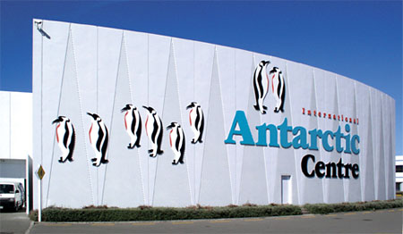
International Antarctic Center
If you've always wanted to romp with penguins, stroke a leopard seal, climb aboard a snowmobile, explore a snow cave, and feel the icy wind chills of Antarctica, this is probably as close as you'll ever get. The penguins may be man-made and the leopard seals stuffed, but everything about this attraction is of superb value. It takes more of a geographic/natural history approach than the Canterbury Museum's Antarctic exhibition, and if you see both, you'll have a healthy appreciation for life on the ice. Considered one of New Zealand's leading attractions, it gives you a feel for modern Antarctic life through sophisticated sound-and-light shows, a spine-tingling audiovisual presentation, and interactive exhibits. The center is suitable for visits of 30 minutes or half a day, but spending 1 to 2 hours is ideal. Two wheelchairs are available for use by the public.
The newest attraction here is the Antarctic Hagglund Ride, the only one of its type in the world. Its 45-minute tour gives you a unique insight into the planning of Antarctic journeys. It's well worth the extra money and a big hit with kids.

Timings: Oct-Mar daily 9am-8pm; Apr-Sept daily 9am-5:30pm

Orana Park
There's something quite magical about getting up close and personal with Harold the Rothschild giraffe and his four lanky pen mates. You can feed them and fondle their ears and they won't mind a bit, but don't try that with the park's lions, tigers, and cheetahs. Set in 80 attractively laid-out hectares (198 acres), the park is New Zealand's largest wildlife reserve. You'll see few fences and cages here -- the emphasis is on a natural environment, which seems to agree with the cheetahs, the only successfully breeding ones in Australasia (10 or so new cubs in the past 12 years). At 3:55pm daily, you can see them make a dash for their raw-meat supper, which is attached to a fast-moving lure. The main lion feeding time is 2:30pm daily. This is the only place in Christchurch to see a tuatara, and there's a nocturnal kiwi house as well, but the one at Willowbank is bigger and better. If you're in a hurry, take the park's 40-minute free shuttle circuit.

Timings: Daily 10am-5pm

TRIP ON THE TRANS ALPINE TRAIN
This is a full day excursion. It is the most scenic train journey in NZD and is from CHC to Greymouth. It takes one 4 hrs 10 min one way. This is for those who are not proceeding to Queenstown via Franz Josef.

SHOPPING
The main shopping areas are the High Street, Cathedral Square, Castle Street, Bridge Street, Church Street, Wick Lane, Saxon Square Shopping Centre and Bargates where you will discover shops selling Designer and High Street fashions, delicious continental chocolates, interesting gifts and treasures, health foods, books and art to name but a few!
Bargates Shopping Center is a great place for some good bargains.

New Zealand is very famous for its pearls. One can see and buy the best Blue Empress Abalone Pearls which is specially grown in Stewart Island at their shop near Cathedral Square. Open from 0930 hrs – 2200 hrs in summers.

PLACES TO SEE AND VISIT FROM CHRISTCHURCH

KAIKORA
Located 2 hrs 50 mins drive, North of CHC is this lovely place which is home to the whales and where one can indulge in a whale watching cruise.
This is a full day excursion which is weather dependent and is a must do.

FRANZ JOSEF GLACIER
An ideal break when one is traveling to Queenstown from Christchurch. This is one place where you are ON the glacier and is a great and different experience. There are NO Indian Restaurants here; however Vegetarian food can be made available.
One can indulge in a half day glacier walking tour or opt for a helicopter ride to the summit of the snowy peaks where they will pack a picnic hamper for you and leave you there in complete privacy. This is a great suggestion for the Honeymooners.

INDIAN RESTAURANTS IN CHRISTCHURCH
Raj Mahal
Indian on the Pier
The Maharaja
Tulsi
Tandoor Palace
Little India
Indian summer
Mantra

ACCOMMODATION IN CHRISTCHURCH
Popular areas include along Bealey Avenue which is just a short walk from the city centre as well as Papanui and Riccarton Roads.

QUEENSTOWN:
Queenstown has over 1 million visitors a year and you don't have to be a genius to figure out why. We've all heard the endless hype about it being the adventure capital of the world, and there are certainly enough crazy activities here to challenge the strongest, but Queenstown offers much more. Don't be put off by comments that it's touristy, un-Kiwi, crowded, and overrated. Sure, the streets are dominated by booking offices, but Queenstown has excellent shopping, restaurants, cafes, and clubs as well. And in many adrenalin-seeking ways, it encapsulates much of what New Zealand is about.

Key Tips
- Queenstown airport welcomes daily flights from New Zealand’s main centres and several flights each week to/from Sydney, Melbourne and Brisbane.
- The downtown area of Queenstown covers less than 2 square kilometres. Most shops and restaurants are within easy walking distance.
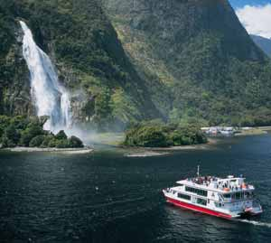
MUST SEE:

Great Sights 'Discover Milford Sound'
A region rich with dense rainforest, lakes and waterfalls cascading from rugged mountain peaks. Cruise the fjord with Milford Sound Boat Cruises where you will see the wonders of Mitre Peak.

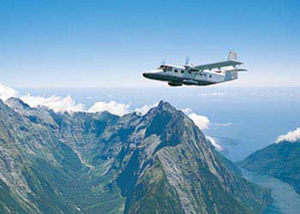
Discover Milford Sound - Coach/Cruise/Fly’
Leave Queenstown and visit Milford Sound for the day on this 9-hour tour. Traveling by coach, boat and plane (weather permitting), highlights of the tour include, Te Anau, Eglinton Valley - ancient alpine beech forest, Mirror Lakes, Homer Tunnel, Fiordland National Park, Milford Sound Red Boat Cruise and a Milford Sound Scenic Flight.

Departs morning and arrives in the afternoon/evening

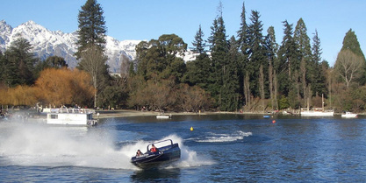
Dart River Jet Safari
Located in queenstown, the dart river jet safari experience is a unique combination of breathtaking scenery, Maori heritage and inspiring adventure – a truly authentic New Zealand discovery. Choose a journey that suits you from the range of amazing safari options
- wilderness safari
- Jet boat safari
- Funyak safari

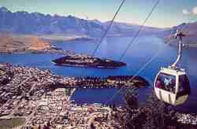
Skyline Gondola
One of the first sights to captivate visitors to Queenstown is the distinctive outline of the Skyline complex high above town.
Located an easy 5 minute walk from central Queenstown and exclusively accessed by scenic gondola, Skyline Gondola, Restaurant & Luge is a'must-see' attraction during your visit to Queenstown, New Zealand.

AJ Hackett - The Ledge Bungy & Swing
400 meters above Queenstown. Bungy jump or swing by day or night. Choose your jump, or opt for the toys - go off on a skateboard, bike, snowboard or in-line skates!
Observe from the outdoor viewing decks or the Skyline Bar.

Queenstown Tandem Paragliding
Take an exhilarating tandem paragliding flight from the top of the Skyline Gondola.
The only company permitted to fly over spectacular Queenstown and Lake Wakatipu.
Soar over town before landing at the bottom of Bob's Peak. Choose from a sedate or aerobatic flight. Flights are weather dependent.

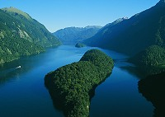
Doubtful sound
Doubtful Sound located in a World Heritage Area, is an overwhelming place. You can feel the power of nature here - the remoteness, the wildness and the peace.
Known for its wilderness and wildlife, Doubtful Sound is the second largest of the 14 fiords in Fiordland National Park and it is three times longer and 10 times larger than Milford Sound.
In Maori legend, the godly figure Tu Te Raki Whanoa created this incredibly beautiful fiord with the assistance of four young sea gods who carved out its sheltered arms.
Today Doubtful Sound remains an unspoilt wilderness of many moods; one minute clear blue and sun-drenched, the next mysterious and mist-cloaked.

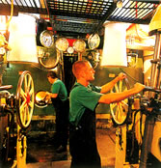
TSS Earnslaw Cruises
Step aboard – watch the stokers fuelling the fireboxes and hear the sound of the steam engines working as the TSS Earnslaw takes you on a cruise of beautiful Lake Wakatipu.
Be transported in style on one of our regular departures to Walter Peak High Country Farm. As you relax on board enjoy delicious café style food or a drink from the bar (extra cost).
Every cruise allows you plenty of time to explore the TSS Earnslaw’s decks and bridge, view the engine room and historic displays in the Fo’c’sle Gallery and join a sing-along with the ship’s pianist.
You can combine the cruise with a visit to Walter Peak High Country Farm for a guided farm visit & barbecue lunch or an evening buffet dining.

Timings: Cruises depart regularly throughout the day

Helicopter scenic flights
Queenstown is a picture perfect alpine paradise set against a backdrop of The Remarkables mountain range and nestled on the shores of Lake Wakatipu. The Helicopter Line's Queenstown base operates from the Queenstown Airport, located just 8 kilometres from the downtown area.

Shot Over Jet Boating
Shotover Jet is situated at Arthurs Point, six kilometers from Queenstown and is the only company permitted to operate in the world famous Shotover River Canyons. They have complimentary courtesy coach transfers for Thrill Therapy seekers from their Queenstown depot (The Station Building) every 15 minutes (allow 1 hour 30 minutes return). It operates all year round and a pre booking is advisable.

Bungy Jumping
A must do here as this is where the sport was born!! The same can be pre booked here.

WANAKA
Lake Wanaka is a place to take a deep breath and relax. Protected from the outside world by the grandeur of the mountains, you’re enclosed in a hidden paradise. It is a 1 hr 50 mins drive from ZQN and a 6 hrs drive to Franz Josef. Hence it is actually the ideal place to break for 2 nights or so enroute to Franz Josef from Queenstown.
Crystal clear lake waters lap the shores of Wanaka town and the feet of the Southern Alps, which are home to winter ski fields and the dramatically alpine Mount Aspiring National Park.
Lake Wanaka is New Zealand's fourth largest; its clean, blue waters are an inland sea for sailors and jetboaters to explore. Walking tracks and bridle trails wander the flats and foothills. In all seasons, outdoor adventures beckon.
The jewel of the region is its highest point, Mount Aspiring (3,027 metres), which nestles comfortably in one of the country’s largest national parks. Delve inside the park's boundaries and discover a rare world.
The place is truly beautiful and we recommend that if the client is doing a self drive programme you must suggest they stay here rather than in Queenstown. Ideal for Honeymooners too.
Tip : there is a fabulous Resort here called the Azur Lodge, very upmarket and must be suggested to all Honeymooners and those who would like the best. ( this was the same place where Fardeen Khan spent his honeymoon for 2 weeks !) – one can tell clients to opt for 3 star hotels at all places and only here to upgrade to this fabulous lodge at least for 2 nts. Well worth it and will be the highlight of their holiday.

INDIAN RESTAURANTS IN QUEENSTOWN:
Little India Bistro & Tandoor
Bombay Palace Indian Restaurant & Takeaways Limited
Freiya's Indian Restaurant

DUNEDIN
A great city – where else can you ascend the world’s steepest street, view a Monet, take lunch in a 19th Century castle, see the world’s rarest yellow eyed penguins and dine in style in an award winning restaurant ?
Its however not a place where one can indulge in shopping.
It is a 4 hrs 25 mins drive from Queenstown or Wanaka or Mount Cook.
MUST SEES –
Moeraki Boulders
Marvelously huge marbles line the beach at Moeraki, 40km south of Oamaru. According to Maori legend, the boulders are gourds washed from the great voyaging canoe Araiteuru when it was wrecked upon landfall in New Zealand some 1000 years ago.
Scientists explain the boulders as septarian concretions formed about 65 million years ago. Crystallization of calcium and carbonates around charged particles in muddy undersea sediments gradually formed the boulders in a process taking as long as 4 million years.
The soft mudstone containing the boulders was raised from the seabed about 15 million years ago and changing sea levels are exposing the erosion-resistant boulders.
The viewing platform, just a few minutes walk through regenerating native shrubland, offers good views of the boulders and, if you are lucky, New Zealand (Hector’s) dolphins playing in the waves can be spotted.

Taieri Gorge Railway
Enjoy this half day award winning excursion on the Taieri Gorge Train into the spectacular Taieri Gorge. At the end of the line is the unique 150 kms Otago Central Rail Trail. The whole journey takes 4 hours.
Cadbury Factory
This is located in the center of Dunedin and is a great place to visit especially with kids. The tour lasts 1 ¼ hrs and explains how some great chocolate is made. The highlight of the tour is the chocolate fall that happens at the end. This is one place where the adults and the kids are one ! the tour operates 7 days a week.
Larnach Castle
This is the ONLY castle in the whole of NZD. One can either visit the same and take a tour of the interiors or even make pre booked arrangements to stay at the Boutique Larnach Lodge on the palace grounds for a night or two. Truly memorable and will be great to include as part of the itinerary. From the Castle tower you can view the Otago Peninsula, where the world's only mainland Royal Albatross Colony and the world's rarest Yellow Eyed Penguins are sited. Gaze around at Dunedin city, Port Otago and the awesome Pacific Ocean.
DISTANCE CHARTS IN NEW ZEALAND ( in hours )

NORTH ISLAND

Auckland – Rotorua = 3 hrs 30 min
Auckland – Wellington = 9 hrs 15 min
Auckland – Waitomo Caves = 3 hrs 10 min
Rotorua – Taupo = 1 hr 20 min

SOUTH ISLAND

Christchurch – Greymouth = 4 hrs 10 min
Christchurch – Franz Josef = 6 hrs 15 min
Christchurch – Mount Cook = 4 hrs 45 min
Christchurch – Kaikora = 2 hrs 50 min
Christchurch – Queenstown = 7 hrs 15 min
Christchurch – Picton = 5 hrs
Franz Josef – Greymouth = 3 hrs 15 min
Queenstown – Dunedin = 4 hrs 25 min
Queenstown – Milford Sound = 5 hrs 05 min
Queenstown – Te Anau = 2 hrs 45 min
Queenstown – Wanaka = 1 hrs 50 min
Queenstown – Franz Josef = 7 hrs 40 min
Queenstown – Mount Cook = 3 hrs 50 min
MOUNT COOK
A spectacular place and an ideal place to stop for at least a night whilst driving up from Queenstown to Christchurch or vv. It takes an approx 3 hrs 50 mins from ZQN and 4 hrs 45 mins from CHC.
It’s a very highly recommended place for Honeymooners.
It is a National Park and Mount Cook is the highest peak in the Southern Alps. The entire area has only 3 types of accommodation. The Hermitage Hotel ( there are 3 categories within – the 3* / 4* and the 5*), Youth Hostel and a motel. The Hermitage Hotel is well worth the stay and if you opt for the 5* category you are assured of rooms that face the Southern Alps.
For those not staying at Mt Cook and just driving through, it is worth stopping at the statue of Sir Edmund Hillary ( he practiced climbing the Tasman Glacier 5 times before he scaled the Everest) and also having lunch at the Hermitage Hotel.
No Indian Restaurants here but vegetarian food is available. To get to Mount Cook one needs to drive across Lake Pukaki.
MUST DOS –
Glacier Landing – board a 7 seater seaplane. The entire duration of the activity is 45 mins starting from Mt Cook Airport. You are flown up to the top of the Tasman Glacier which is the longest glacier in the world.
Tip – for honeymooners we can arrange at an extra cost for them to have champagne arranged atop the glacier.
Glacier Explorer Tour – This involves a boat ride on the Tasman Lake. A fabulous experience.
Glacier Walk – Experience the glacier first hand by walking on it with experienced trekkers. You are taken on 4 WD vehicles to the start of the glacier from where the walk begins. The walk is much more accessible from here and is well worth it.

